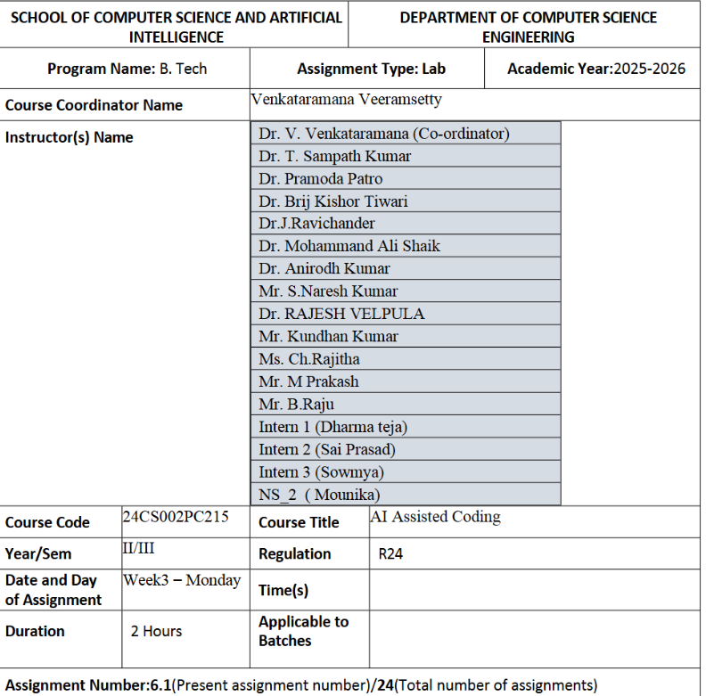
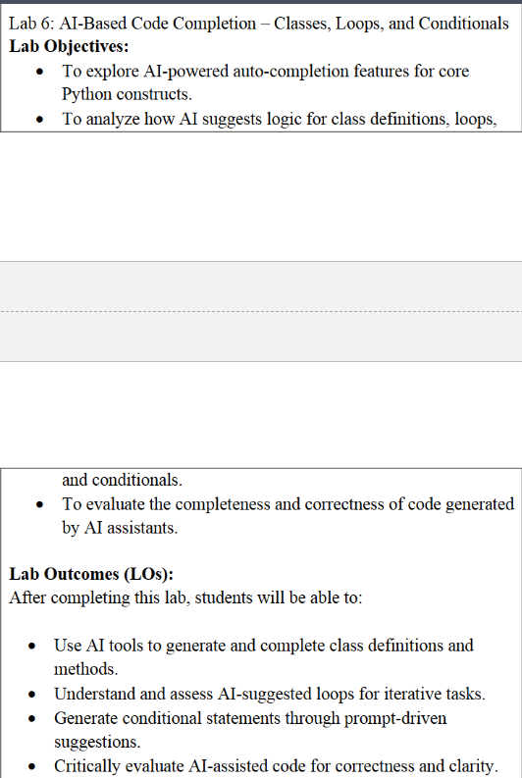
Task Description #1 (Classes – Employee Management)
• Task: Use AI to create an Employee class with attributes (name,
id, salary) and a method to calculate yearly salary.
• Instructions:
o Prompt AI to generate the Employee class.
o Analyze the generated code for correctness and structure.
o Ask AI to add a method to give a bonus and recalculate
salary.
Expected Output #1:
• A class with constructor, display_details(), and calculate_bonus()
methods
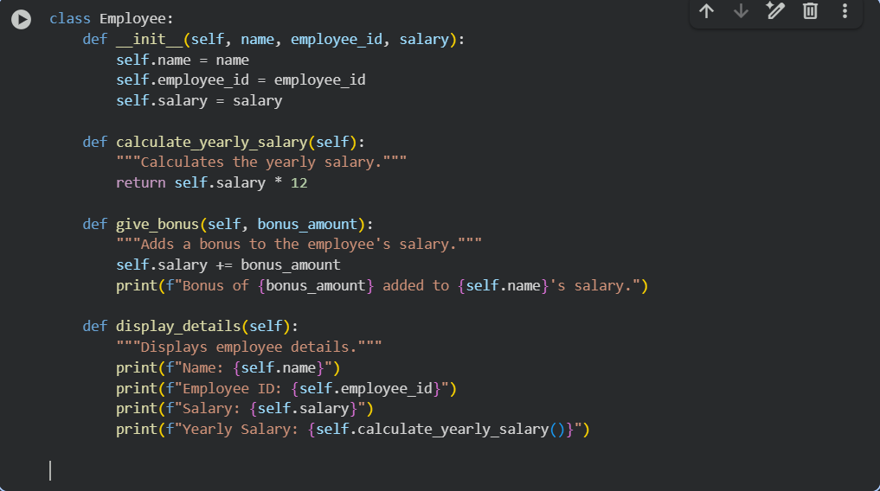
Task Description #2 (Loops – Automorphic Numbers in a Range)
• Task: Prompt AI to generate a function that displays all
Automorphic numbers between 1 and 1000 using a for loop.
• Instructions:
o Get AI-generated code to list Automorphic numbers using
a for loop.
o Analyze the correctness and efficiency of the generated
logic.
o Ask AI to regenerate using a while loop and compare both
implementations.
Expected Output #2:
• Correct implementation that lists Automorphic numbers using
both loop types, with explanation.
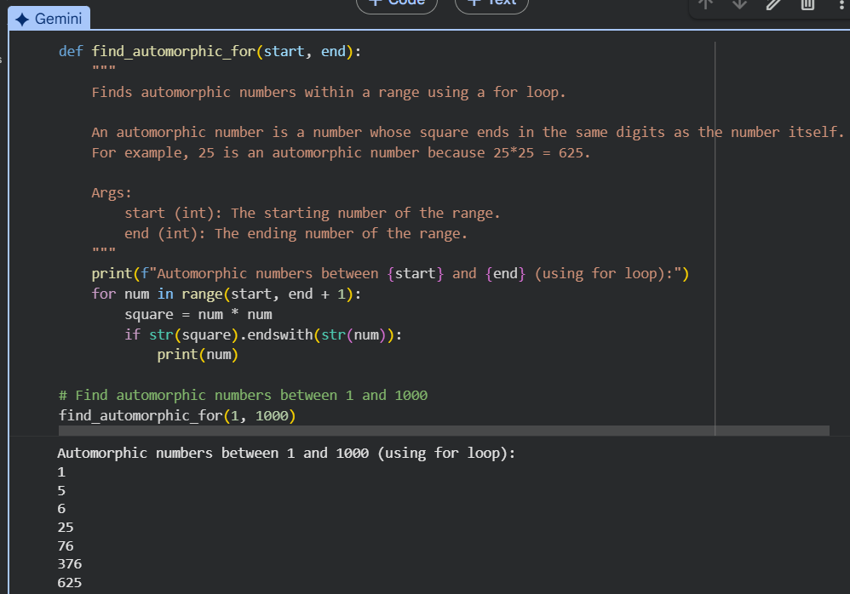
Task Description #3 (Conditional Statements – Online Shopping
Feedback Classification)
• Task: Ask AI to write nested if-elif-else conditions to classify
online shopping feedback as Positive, Neutral, or Negative based
on a numerical rating (1–5).
• Instructions:
o Generate initial code using nested if-elif-else.
o Analyze correctness and readability.
o Ask AI to rewrite using dictionary-based or match-case
structure.
Expected Output #3:
• Feedback classification function with explanation and an
alternative approach
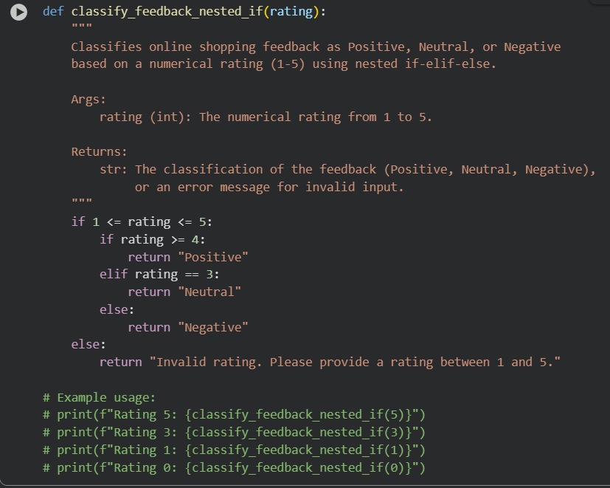
Task Description #4 (Loops – Prime Numbers in a Range)
• Task: Generate a function using AI that displays all prime
numbers within a user-specified range (e.g., 1 to 500).
• Instructions:
o Get AI-generated code to list all primes using a for loop.
o Analyze the correctness and efficiency of the prime-
checking logic.
o Ask AI to regenerate an optimized version (e.g., using the
square root method).
Expected Output #4:
• Python program that lists all prime numbers within a given range,
with an optimized version and explanation
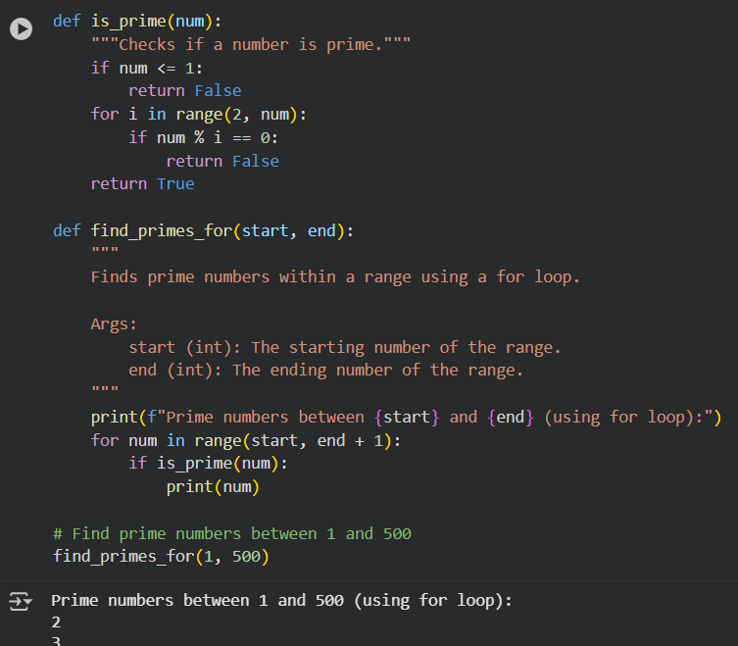
Task Description #5 (Classes – Library System)
• Task: Use AI to build a Library class with methods to
add_book(), issue_book(), and display_books().
• Instructions:
o Generate Library class code using AI.
o Analyze if methods handle edge cases (e.g., issuing
unavailable books).
o Ask AI to add comments and documentation.
Expected Output #5:
• Library class with all methods, inline comments, and explanation.
